# COBOL vs Python (GenAI converted) Test results comparison

## COBOL Test Execution

### Runtime:

Open source COBOL run time GNUCobol

<https://gnucobol.sourceforge.io/>

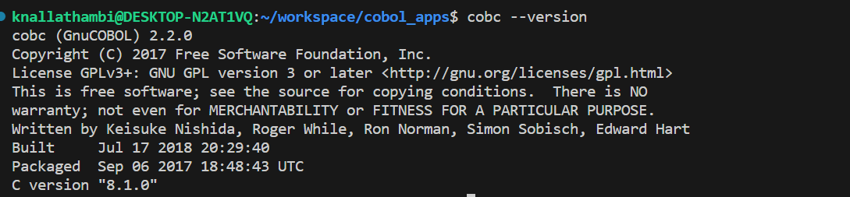

### PINVRPT Source Code:

Program: PINVRPT.cbl



FILE-CONTROL changed according to GNUCobol runtime

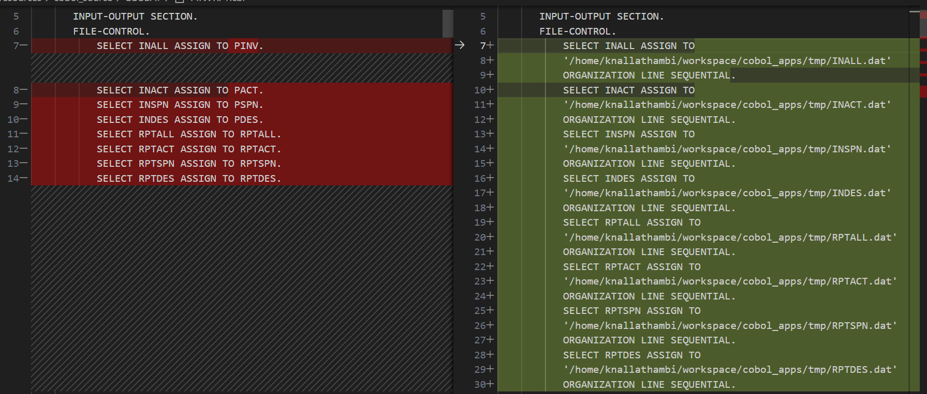

Compile and generate executable



### PINVRPT Run Test:

Input files:



Run the COBOL code:

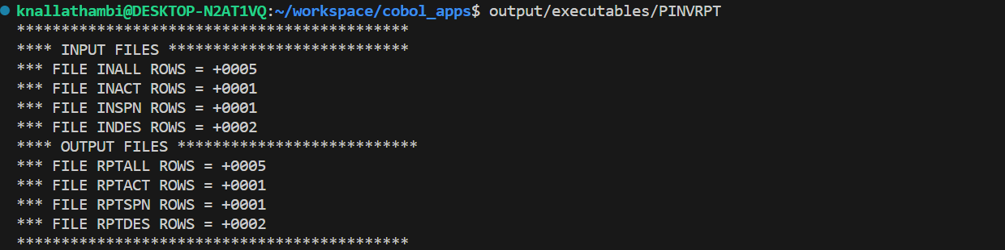

Output files:



## OpenAI Generated Python Test Execution

### Runtime:

Python 3.10.11

### PINVRPT Source Code:

Program: PINVRPT.py



### PINVRPT Run Test:

Input files:



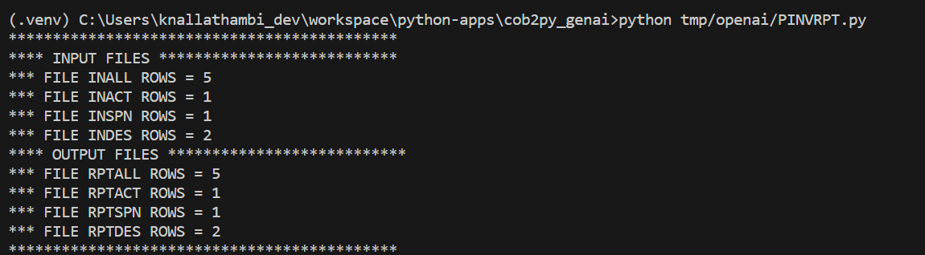

Output files:



### PINVRPT Result comparison with COBOL run:

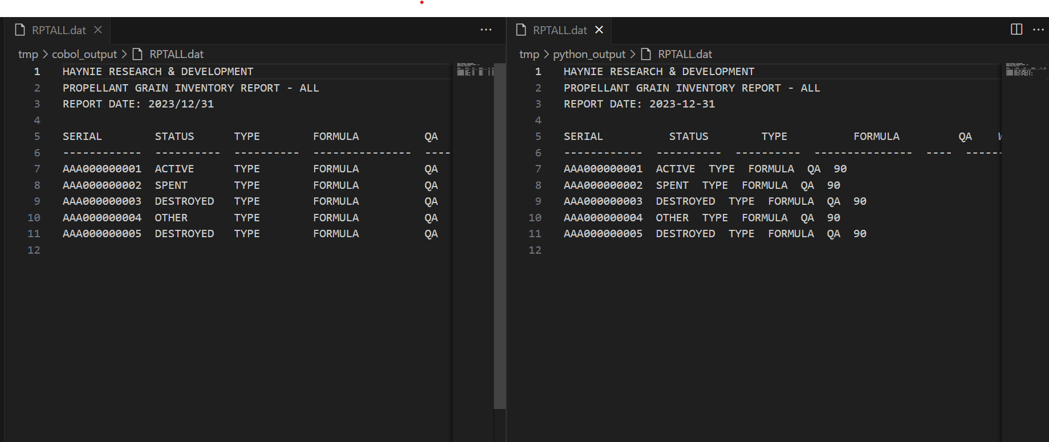

Observations:

* Data values are correct in the output in all 4 report files. STATUS field conversion logic is applied correctly
* Report formatting is incorrect in the Python output in all 4 report files

## Google Generated Python Test Execution

### Runtime:

Python 3.10.11

### PINVRPT Source Code:

Program: PINVRPT.py



### PINVRPT Run Test:

Input files:



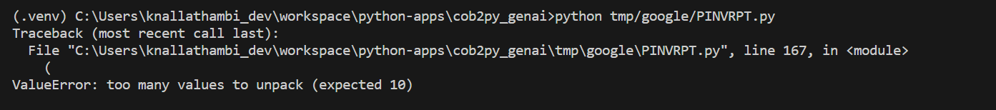

The Generated Code has logic issues in parsing the Fixed width input records.

### PINVRPT Manually fix file parsing issues:



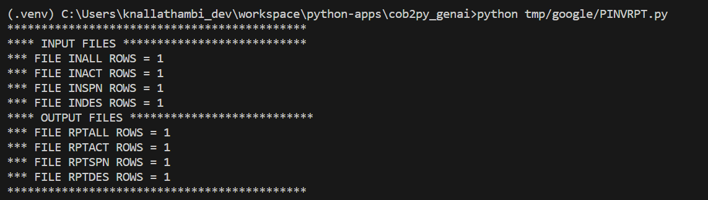

Output files:



### PINVRPT Result comparison with COBOL run:

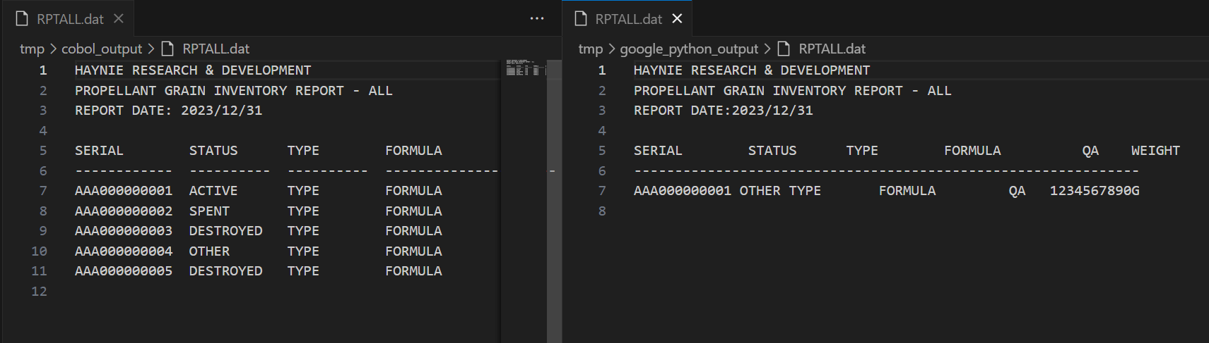

Observations:

* Misses the output records and values in all 4 files. STATUS field logic not applied correctly.
* Formatting is not captured in the output files